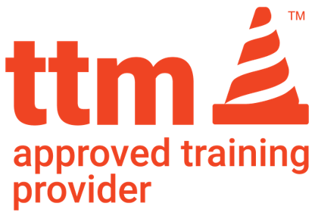
AUSTROADS UTILITY WORKER TRAINING DECLARATION
ATP NAME: Star Training and Assessing
To Star Training and Assessing – We wish to confirm that the employee(s) listed below are currently employed as a utility worker either directly or indirectly meeting the definition below.
The Utilities Temporary Traffic Management (TTM) Worker Accreditation course is designed for all workers employed directly or indirectly by a Utility organisation that provides basic public needs such as water, gas, electricity, communications.
Indirectly refers to companies who solely work to provide services to a provider of electricity, gas, water or communications.

COMPANY NAME:
NAME/S OF WORKER/S:
1
2
3
4
5
6
7
8
If more names are required, please write these on the back of this form.

If you have any additional questions please contact:
NAME: |  | POSITION:
PHONE:
EMAIL:

Kind Regards
Name:

Signature:

Please have students bring a copy of this form on the day of Training or alternatively you can email traffic@startraining.com.au

